**Programming Assignment 3, 7A - Code**

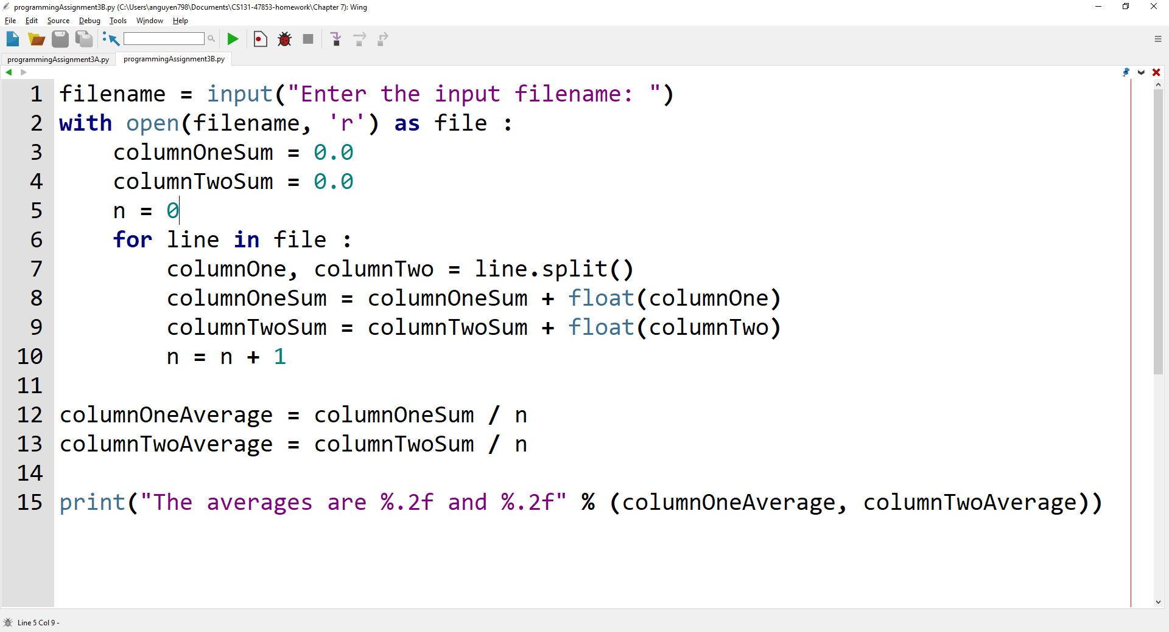

**Programming Assignment 3, 7A - Output**

**Folder – Before running Code**

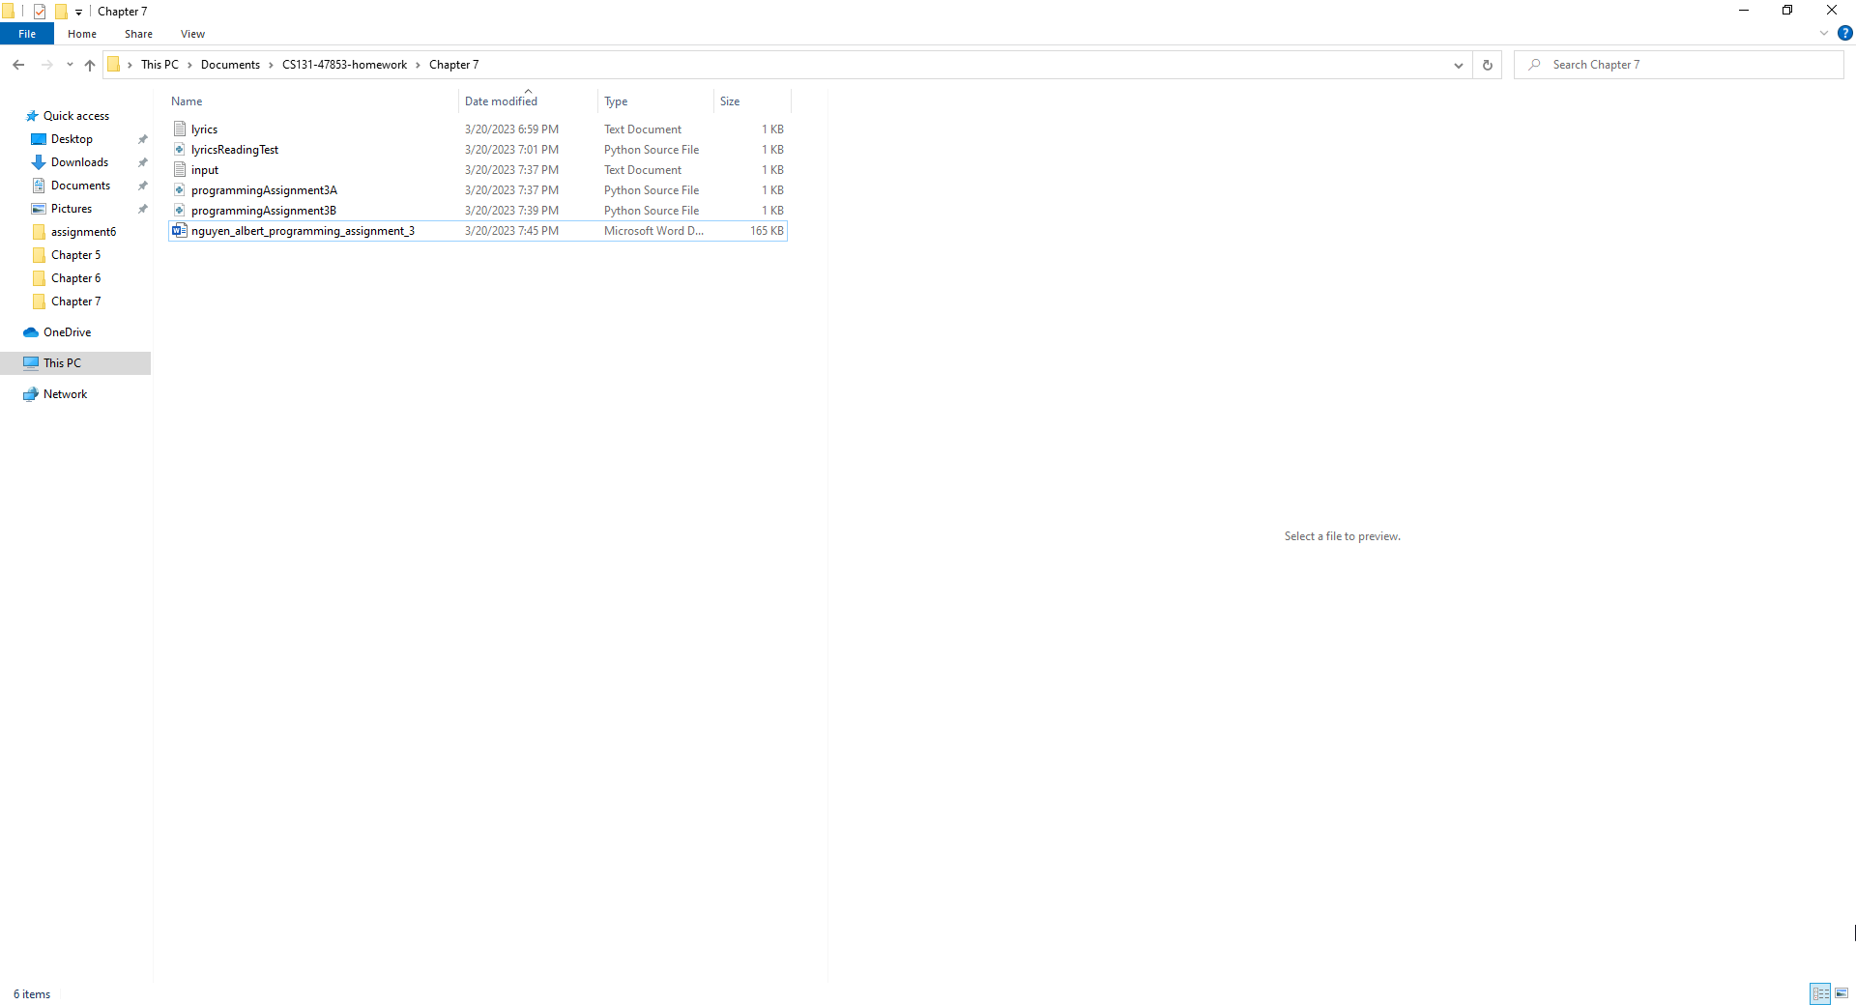

**Folder – After running Code**

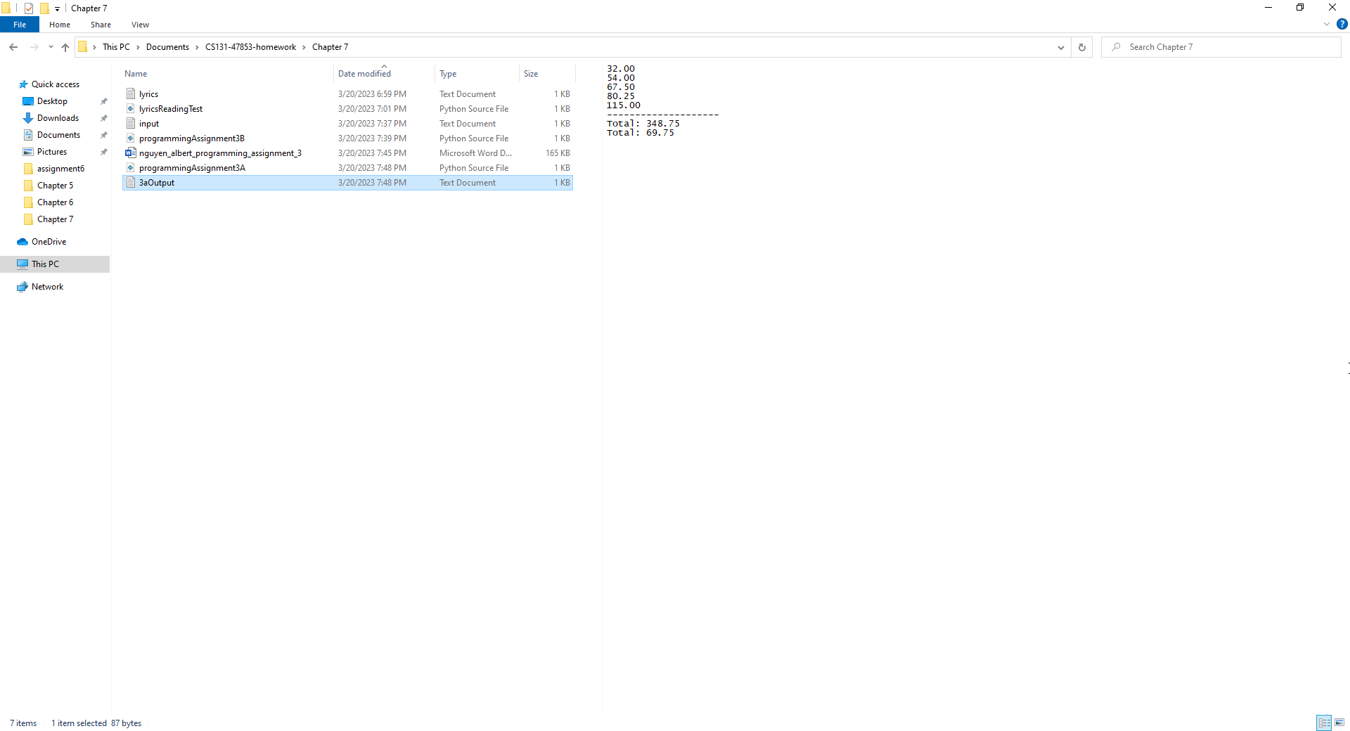

**Programming Assignment 3, 7A - Written Code**

list = [32.0, 54.0, 67.5, 80.25, 115.0]

listTotal = sum(list)

listAverage = listTotal / len(list)

with open('3aOutput.txt', 'w') as outputFile:

    for integer in list :

        outputFile.write('%.2f\n' % integer)

    outputFile.write('-' * 20 + '\n')

    outputFile.write('Total: %.2f\n' % listTotal)

    outputFile.write('Total: %.2f\n' % listAverage)

**Programming Assignment 3, 7B - Code**



**Programming Assignment 3, 7B - Output**

**Reading from input.txt**

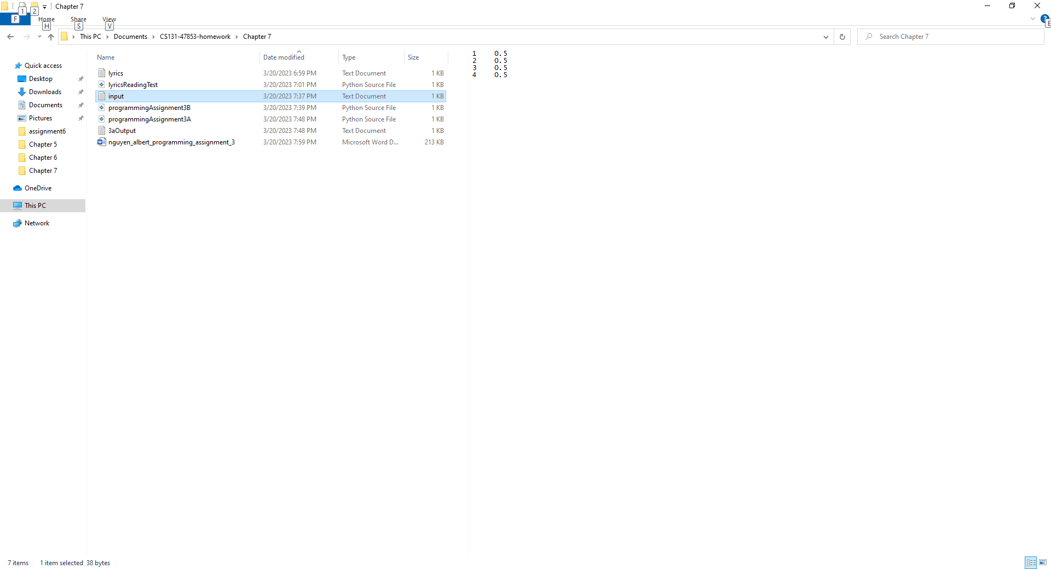

**7B Console Output**

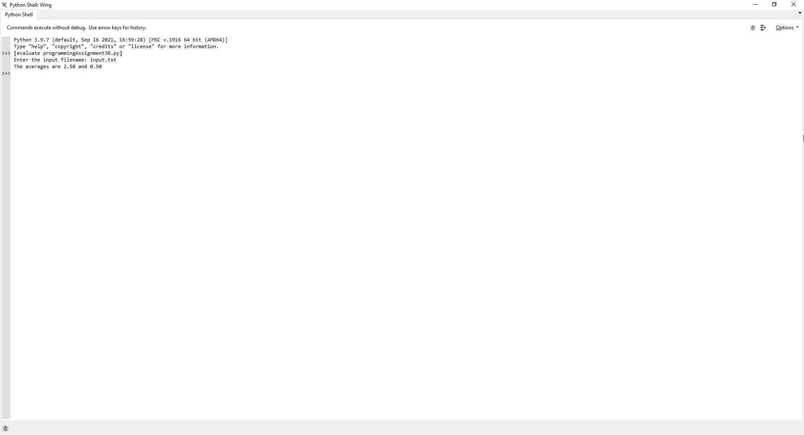

**Programming Assignment 3, 7B - Written Code**

filename = input("Enter the input filename: ")

with open(filename, 'r') as file :

    columnOneSum = 0.0

    columnTwoSum = 0.0

    n = 0

    for line in file :

        columnOne, columnTwo = line.split()

        columnOneSum = columnOneSum + float(columnOne)

        columnTwoSum = columnTwoSum + float(columnTwo)

        n = n + 1

columnOneAverage = columnOneSum / n

columnTwoAverage = columnTwoSum / n

print("The averages are %.2f and %.2f" % (columnOneAverage, columnTwoAverage))